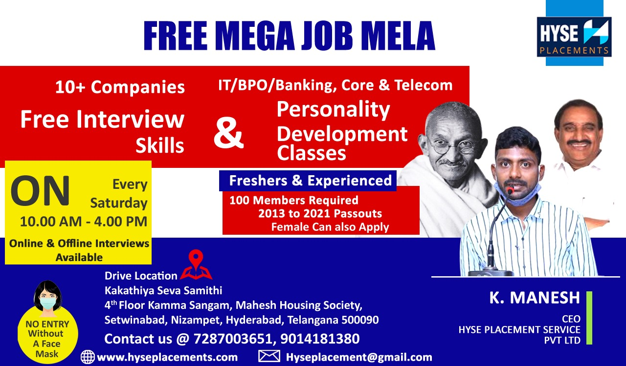

**HYSE Placements & Digital Academy**

**www.hyseplacements.com**

**www.hysedigitalacademy.guru**

**(All the below services are Free)**

**We Provide Training on 8 Domains’**

**(Java, UI+UX, Data Science+ Python+ AI+ ML, Testing, Digital Marketing, Content Writing, Spoken English + MS Office+ MS Excel + Communication Skills, Interview Preparation + Personality Development)**

|  |  |  |  |
| --- | --- | --- | --- |
| **Course Details** | | | |
| **Course** | **Timings** | | **Course Duration** |
| **Morning Batch** | **Evening Batch** | **3 Months** |
| **DATA SCIENCE** | **7.00 AM to 8.00 AM** | **7.00 Pm to 8.00 PM** |
| **JAVA** | **7.00 AM to 8:30 AM** | **7:00 PM to 8:30 PM** |
| **UI&UX** | **8.00 Am to 9.00 Am** | **8.00 PM to 9.00 PM** |
| **TESTING** | **8:30 AM to 10:00 AM** | **8:30PM to 10:00 PM** |
| **DIGITAL MARKETING** | **10:00 AM to 11:30AM** | **5:00PM to 6PM** |
| **CONTENT WRITING** | **-----** | **8:00 PM to 9:00PM** |
| **Ms Excel**  **+**  **Ms office**  **+**  **Communication Skills**  **+**  **Spoken English** | **9:00 AM to 10:00 AM** | **5.00 PM to 6.00 PM** |
| **Interview skills, Resume Making**  **&**  **Personality Development** | **-----** | **For IT Students**  **3.00 PM to 4.00 PM**  **-------**  **For Non IT Students**  **4.00 PM to 5.00 PM** |

**We Provide**

* **Training + Internship + Working live Project + Internship + certification + Job Assistance.**
* **We Provide Every Month Free Training For 600 Students on Different IT Domains**
* **We Provide Top 6 Companies Interviews on 3rd Month of Training period.**
* **Rules and Criteria To join our Academy**
* **Should Have 50% In last Academic year**
* **Should have minimum 70+% To receive placement assistance or certificate**

**Important Note**

**We are providing Part time work for our Training Students where they can earn 5000Rs to 10000Rs per Month by working 1Hour on Online**

# Digital Marketing Course

**Contents**

# Word Press

* Themes
* Plugins
* Page Builder
* How to Create Word press Website

# Copy Writing

* Head Line Writing
* WIIFM
* How to convert Features into Benefits
* Story Telling
* Case Studies Writing

# SEO

* How Search Engine Works
* 200 SEO Factors
* Off page SEO
* On page SEO
* Best SEO Tools

# Google Analytics

* Account Creation and Dashboard
* Uses of Google analytics
* A A B C
* How to get best out of it

# Pay Per Click

* Account Hierarchy
* Keyword Research
* How to Create Account
* Campaign Creation
* Ad Group Structuring
* Conversion Tracking
* Bidding strategy
* Quality Score and Ad rank

# Google Tag Manager

* Account Creation
* Dashboard
* How to create a tag
* How to add GTM Code to Word press Website

# Social Media marketing

* Platforms
* Content Planning
* Paid marketing
* Bidding Strategies

# Email Marketing

* How Email Marketing Works
* Best Email Marketing Platforms Available
* How to create a successful Email marketing Campaign
* Advanced Email Marketing Tips

|  |
| --- |
| **“Thank you, Looking forward to Hear from You.”** |
|